KING EDWARDS AND SWAKELEYS MEDICAL CENTRE

How to register for online prescrition via patient access?
To register for Online services, you will need a linkage key ID provided by the surgery.
- Please fill and return by email/post the Patient Online Registration Form which is available at the surgery or on our website (prescription section) so we can help you with the registration. All registrations require photo ID or
- Please contact us on 01895632114/632021
Once you have received the information from our surgery, please follow the next steps:
- Visit https://www.patientaccess.com/
- Register with Patient Access
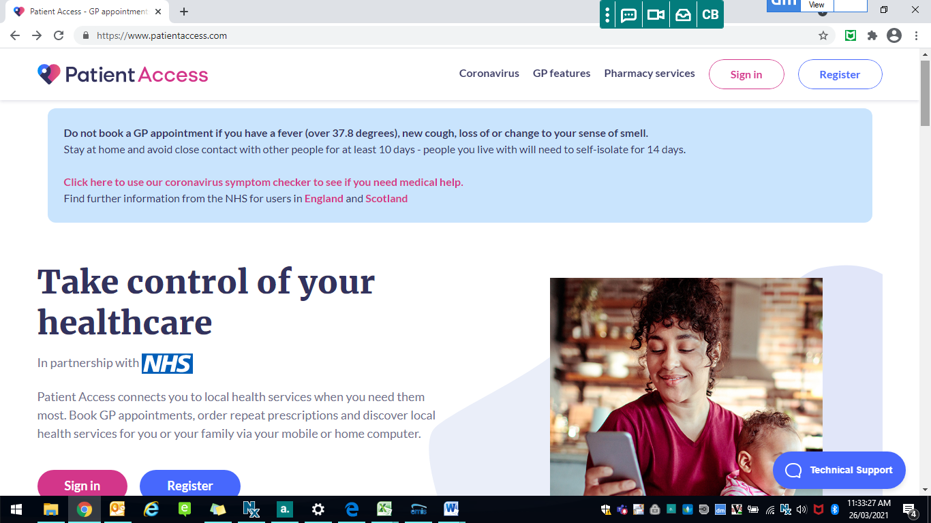

- Add your name and contact details.
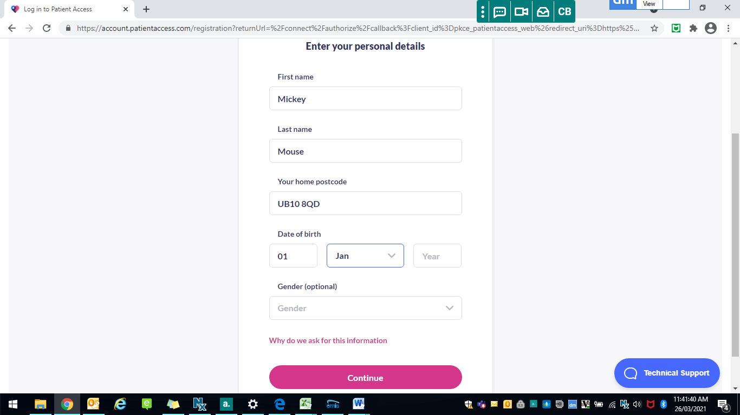

- Enter your email and create a password.
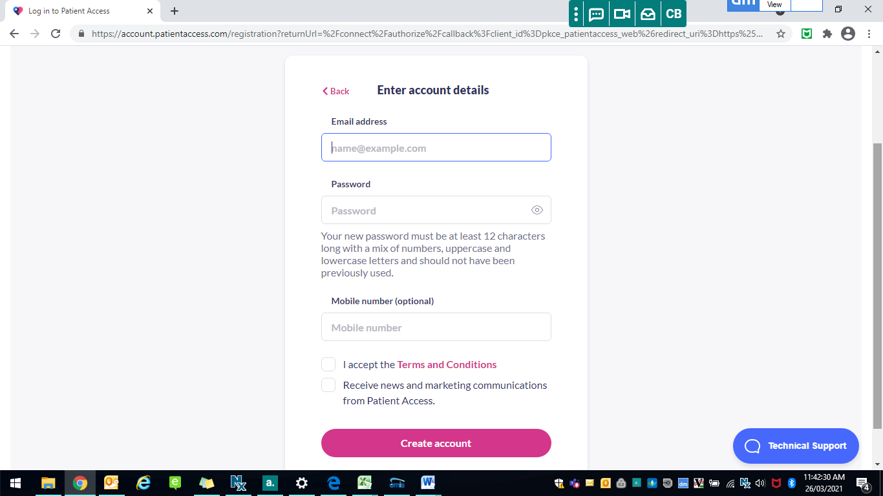
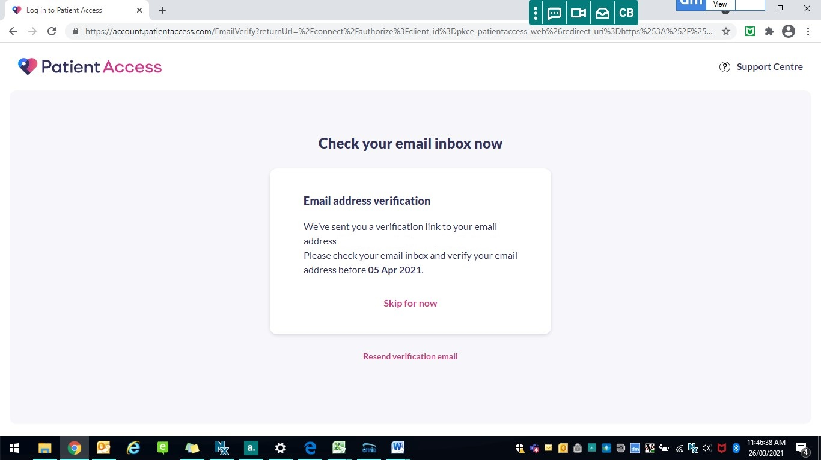

- You will be asked to add your password and create a memorable word.
- You will receive two emails:
First email is a welcome email from Patient Access.
Second email is to verify your identity by Patient Access. It is very important to save the memorable word as you will need enter it during the login.
- Sign in to your account.

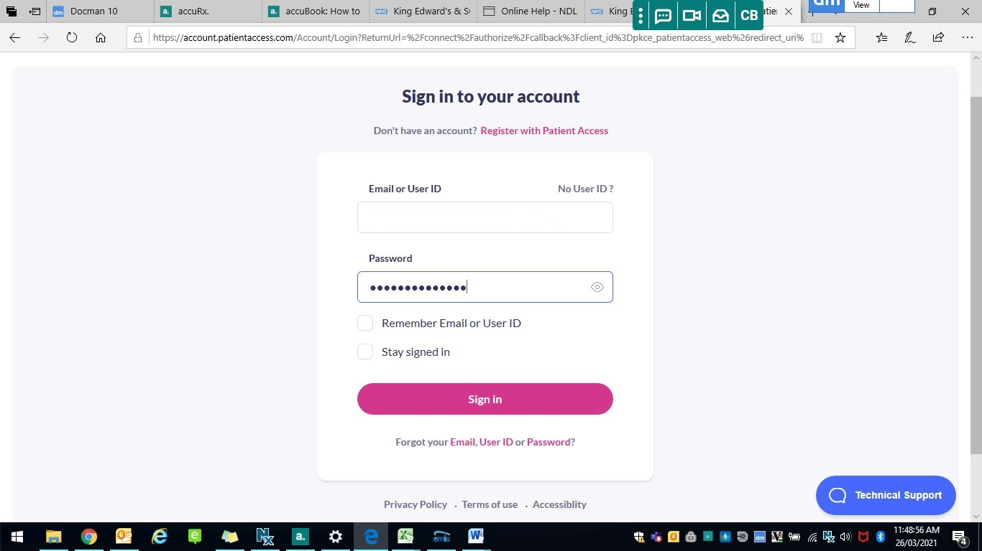

- Link your GP
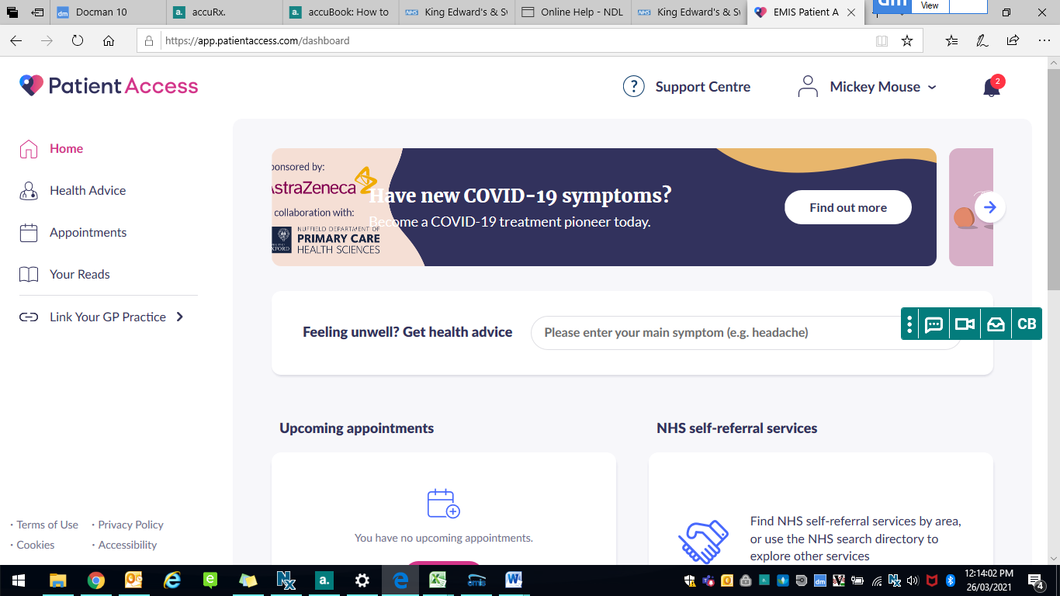
- Select your GP
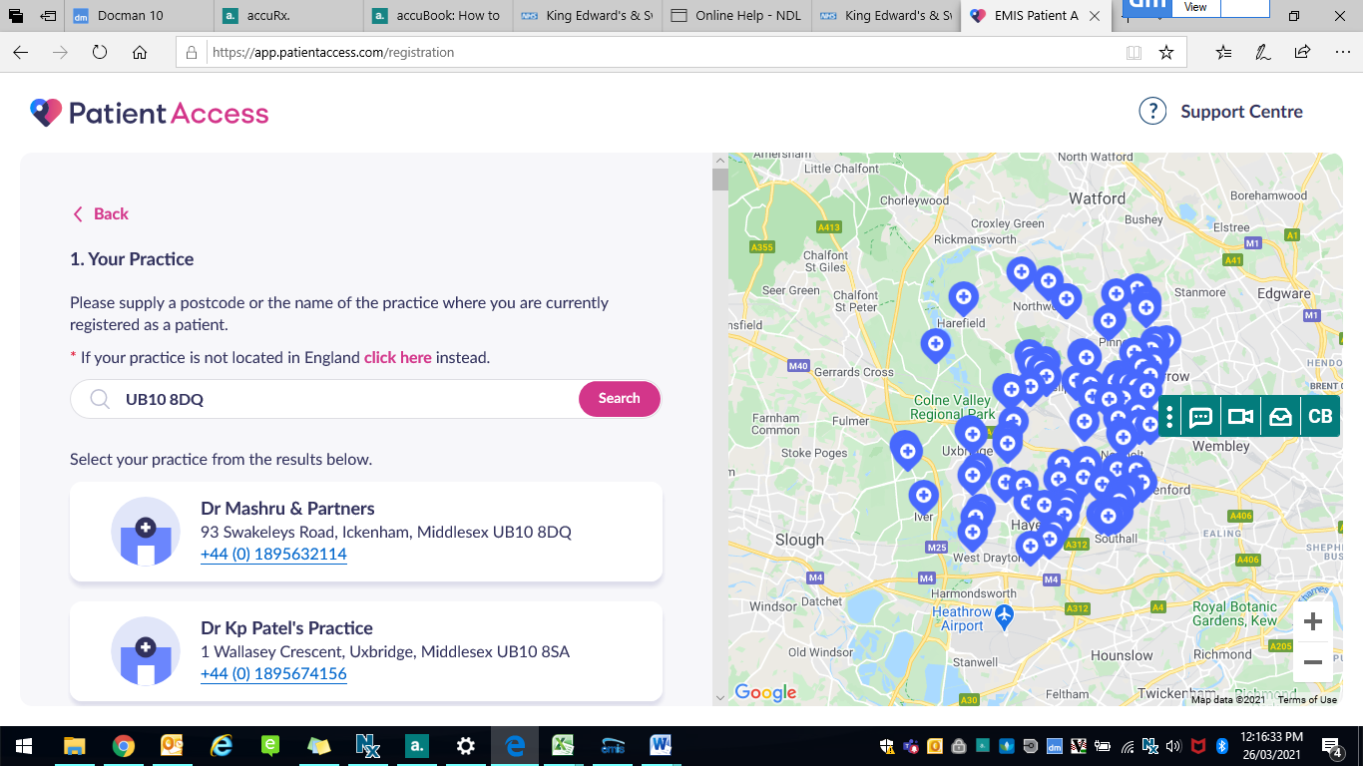

- If you have not been registerd for Patient Access with your Practice, you will not be able to link a GP. See below message:

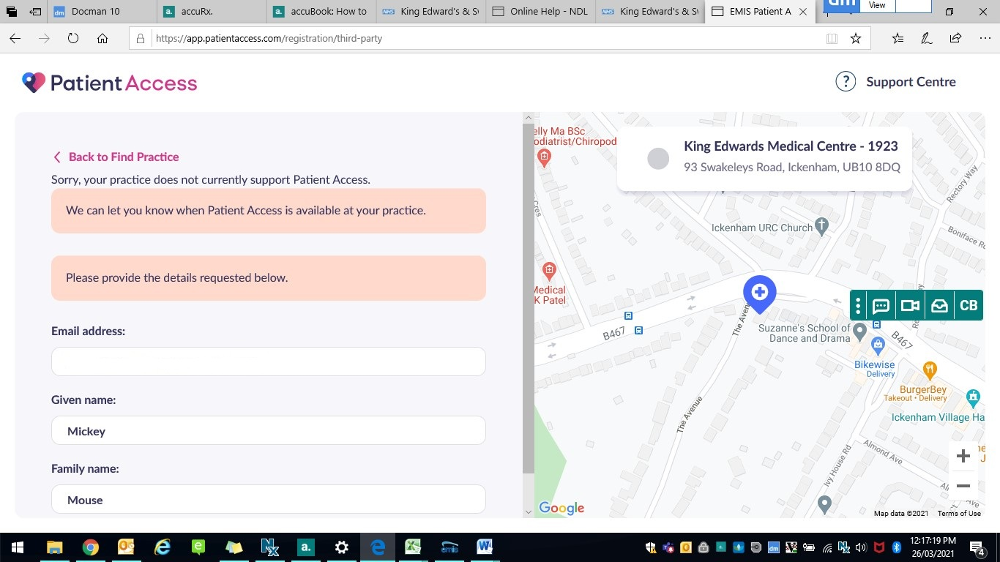

- Once your account has been linked with the surgery, you will be able to request your Repeat Medication.

